Emily Tenenbaum 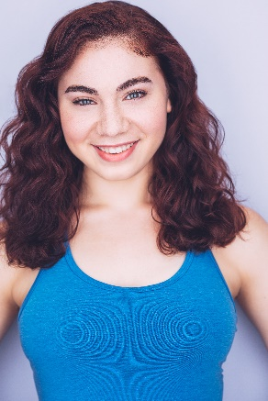

(516)780- 5446 etenenbaum96@gmail.com

Height: 5’ 6” Vocal Type: Soprano (High Belt)

Theatre
Into The Woods Bakers Wife CAP21/ Travis Geisler & Nate Bertone
What Does the World Need Now? Soloist CAP21/ Marshall Keating
Camp Eaglewood Jade CAP21/ Marshall Pailet
Bare Nadia Lighthouse Theatre Co. / Trevor O’Brien
Daniel: An American Tragedy April Post Theatre Co. / Tyler Matos
Ragtime Mother Cultural Arts Playhouse/Tony Frangipane
Spelling Bee Logainne Second Stage Theatre Co. / Brian Stalter
Les Miserables Fantine Cultural Arts Playhouse/ Bruce Grossman
Working The Waitress The Usdan Center/ Scott Saperstein
Footloose Rusty Cultural Arts Playhouse/ Bruce Grossman
My Favorite Year Ensemble Broadhollow Theatre Co. / Laura Wallace

Training
BFA Theater Arts- Molloy/CAP21 Conservatory Class of 2018
Voice: Rob Rokicki, Heather Petruzelli, Marshall Keating, David Kelso
Acting: Marshall Pailet, Larry Arancio, David Hibbard, Sean Dougherty, Frank Ventura
Dance:
Tap [12]: Derek Roland, John Scaccetti
Jazz [9]: Ryan Jackson, Lloyd Culbreath, Lori Leshner
Ballet [6]: Marilyn D’Honau, Ashley Eichbauer-Newman
Masterclasses: Jason Robert Brown (13), Lindsay Mendez (Technique)

Special Skills
Front walkover, Roundoff, Handstand, Trampoline tricks, Ice/roller-skating, crossed eyes, Britney Spears impression, NY Driver’s License

